Content Management Portal (CMP) Project
Database Design Document

Document Reference: |  |  | CMP/DOCS/TS.7
Project: |  |  | Content Management Portal (CMP)
Document Title: |  |  | Database Design
Version: |  |  | 1.0
Date: |  |  | 05 Aug 2009
Prepared/Revised by: |  |  | Rajendran Kumaraguru
 |  | © 2009  The information contained in this document is the property of ISS. The contents must not be copied in whole or in part for purposes other than which it has been supplied without the consent of ISS, or, if it has been furnished under contract to another party, as expressly authorised under that contract, then ISS shall not be liable for any errors or omissions. |  |  | 
Institute of Systems Science, 25 Heng Mui Keng Terrace,
Singapore 119615
Version History Record
Version | Date | Brief description of amendments and affected pages, paragraph
0.1 | 05/08/09 | Draft Issue
1.0 |  | Release after Internal Review

Name | Department | Organisation
ISS Audit | ISS | ISS

Table of Contents
1. Introduction 5
2. List of tables 5
3. DB Diagram 8
4. Tables Structure 10
4.1 MCQ EXAM MASTER 13
4.2 MCQ SECTION MASTER 14
4.3 MCQ QUESTION MASTER 15
4.4 MCQ CHOICE MASTER 16
4.5 MCQ EXAM 16
4.6 MCQ EXAM RESULT 17
4.7 SURVEY MASTER 18
4.8 SURVEY QUESTION MASTER 19
4.9 SURVEY CHOICE MASTER 21
4.10 SURVEY RESULT 21
4.11 MODULE MASTER 22
4.12 COMPANY MODULE 23
4.13 SURVEY CHOICE MASTER 24
4.14 COMPNAY SITES 25
4.15 USER ROLE 26
4.16 DAP MODULE 27
4.17 FAP LIST 28
4.18 COMPANY MASTER 29
4.19 USER ,ASTER 31
4.20 FAP MASTER 32
4.21 DAP MASTER 32
4.22 CMS DIVISION 33
4.23 CMS MODULE 34
4.24 CMS MODULE ADMIN 35
4.25 CMS OBJECTS 36
4.26 CMS MODULE CJ CATEGORY 37
4.27 CMS MODULE HTML 38
4.28 PAGE MODULE 39
4.29 CMS PAGE 40
4.30 CMS COLUMN EXTENSION 41
4.31 CMS COLUMN TYPE 42
4.32 CMS PAGE EXCLUDE 42
4.33 CMS SITE 43

Introduction
This document describes about initial database design for the CMP application. It contains various database tables which are going to be implemented across different modules of the application. The database is designed in db normalization structure. Each table is having the associations with either master or detail table. During the development phase some part of the tables would be changed according to the development.

List of tables
Below table gives the summary of usage of the each tables which will be created for Content Management Portal Application.
Sl No | Table Name | Description
1 | Company_Master | Stores the company information while registering the company.
2 | User_master | Stores the user information upon successful registration of the company.
3 | Fap_master | List of program will be identified and stored for the entire system.
4 | Dap_master | List of data access will be stored for the entire system to restrict the data access at different company levels.
5 | Role_master | Different type of roles will be created for the entire system access. Each role contains several faps and daps and it will be assigned to particular user or group of users.
6 | Mcq_master | MCQ main information will be stores like particular mcq will belong to which section and module.
7 | Mcq_pool_master | List of questions will be stored under this table for MCQ.
8 | Mcq_answers | List of answers will be stored for each mcq.
9 | Mcq_tran_details | When the customer attends the mcq portion the complete transaction details will be stored.
10 | Module_master | Module master information will be stored in this table.
11 | Content_master | Store the uploaded content information in this table which contains section for the uploaded content, total pages as well as property of the uploaded content.
12 | Content_properties | Uploaded content property information will be stored under this table.
13 | Cms_subscription_details | Stores the subscription details for the content. Whenever the customer visits the particular content those information will be stored under this table.
14 | Cmp_survey | Master table which stores the survey information.
15 | Cmp_survey_trans | Detail table which stores the survey transactions details.
16 | Cms_div | Stores the division information for the uploaded content. And it will have either child divisions and parent division of the uploaded content.
17 | Cms_mod | Each uploaded content module will be stored with respective site id and name of the module.
18 | Cms_mod_admin | Stores the module information as well as property of uploaded module.
19 | Cms_obj | Contains module object information.
20 | Cms_mod_cj_category | If there is any insertions into the existing module those information will be stored under this table.
21 | Cms_mod_html | Each uploaded content html information will be stored under this table like site url version folder name etc.
22 | Cms_page_mod | Stores uploaded content page information in this table.
23 | Cms_col_ext | If there is an inclusion into the existing sections of the uploaded content those information will be stored under this table.
24 | Cms_col_type | Internal table to store the column types of the uploaded content.
25 | Cms_page | Store the uploaded content pagination information for the tree view of the application.
26 | Cms_site | Stores the uploaded site url for the uploaded content.
27 | Cms_col | Internal table to store the uploaded content column details.
28 | Cms_page_mod_exclude | If any particular page of the module has to be excluded from the uploaded content those information will be stored under this table.

DB Diagram
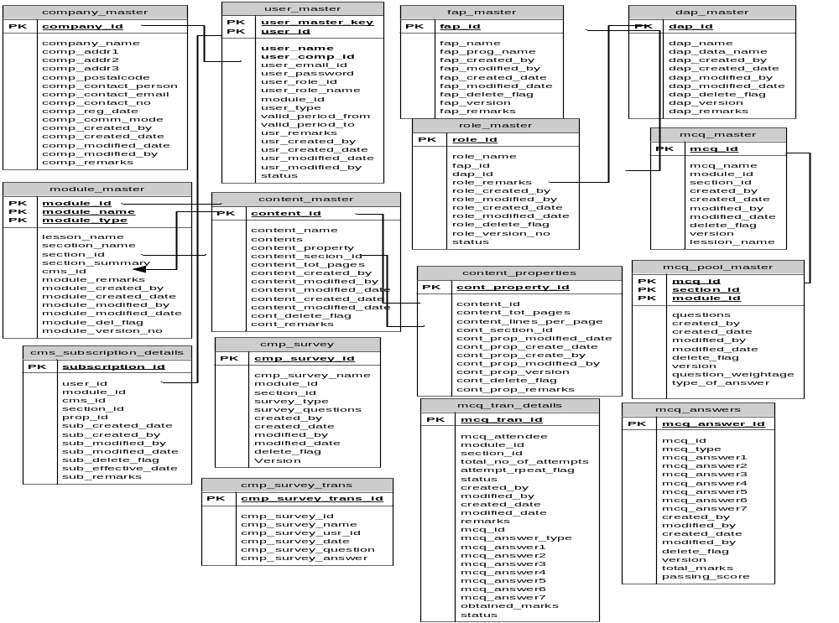

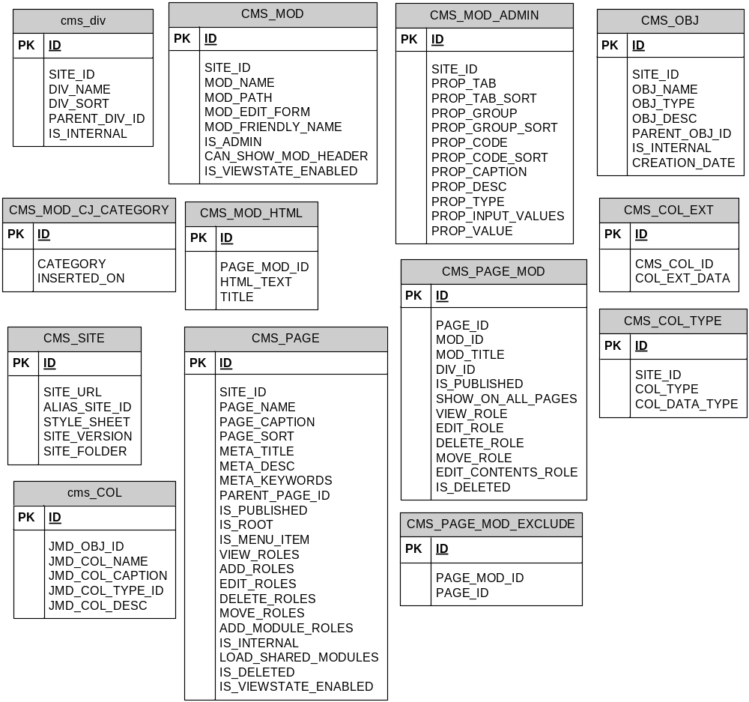

Tables Structure

MCQ EXAM MASTER
Table Name | MCQ_EXAM_MASTER
Module | MCQ
Description | This table store the MCQ (Multiple Choice Question) details

No | Column Description | Data Type & Size | Remarks
1 | EXAM_ID | VARCHAR(25) | Stores the examination ID
2 | EXAM_NAME | VARCHAR(50) | Stores the examination Name
3 | EXAM_ABBR | VARCHAR(50) | Stores the examination details.
4 | TOTAL_QNS | [NUMERIC](5, 0) | Total questions for each exam id
5 | TOTAL_MARKS | [NUMERIC](3, 0) | Total Marks for each exam id
6 | PASS_MARK | [NUMERIC](2, 0) | Total pass mark for each exam id
7 | EXAM_DURATION | [NUMERIC](10, 3) | Duration of the exam. This will be tracked during the examination.
8 | CREATED_BY | VARCHAR(50)
9 | CREATED_DATE | [DATETIME]
10 | MODIFIED_BY | VARCHAR(50)
11 | MODIFIED_DATE | [DATETIME]
12 | DELETE_FLAG | VARCHAR(2)

MCQ SECTION MASTER
Table Name | MCQ_SECTION_MASTER
Module | MCQ
Description | This table stores the section detail for the associated exam id for list of questions for each section.

No | Column Description | Data Type & Size | Remarks
1 | EXAM_ID | VARCHAR(25) | Stores the examination ID
2 | SECTION_ID | VARCHAR(20) | Store the section id for the particular module.
3 | SECTION_NAME | VARCHAR(50) | Stores the section name for the particular module.
4 | SECTION_ABBR | VARCHAR(50) | Stores the abbreviation detail for the particular module.
5 | SECTION_SEQ | [NUMERIC](3, 0) | Under each module the sequence of the module will be stored here.
6 | SECTION_WEIGHT | [NUMERIC](3, 0) | Each section the weight age of the marks will be stored.
7 | TOTAL_SIMPLE_QNS | [NUMERIC](3, 0) | If any sample questions then it stores the total no. of questions.
8 | SIMPLE_QN_WEIGHT | [NUMERIC](3, 0) | Each section the weight age of the marks will be stored.
9 | TOTAL_MODERATE_QNS | [NUMERIC](3, 0) | If any moderate questions then it stores the total no. of questions.
10 | MODERATE_QN_WEIGHT | [NUMERIC](3, 0) | Each section the weight age of the marks will be stored.
11 | TOTAL_COMPLEX_QNS | [NUMERIC](3, 0) | Stores the total complex questions per module and per exam.
12 | COMPLEX_QN_WEIGHT | [NUMERIC](3, 0) | Stores the weight age of each section.
13 | CREATED_BY | VARCHAR(50)
14 | CREATED_DATE | [DATETIME]
15 | MODIFIED_BY | VARCHAR(50)
16 | MODIFIED_DATE | [DATETIME]
17 | DELETE_FLAG | VARCHAR(2)

MCQ QUESTION MASTER
Table Name | MCQ_QUESTION_MASTER
Module | MCQ
Description | This table stores the question detail with associated section.

No | Column Description | Data Type & Size | Remarks
1 | EXAM_ID | VARCHAR(25) | Stores the examination id
2 | SECTION_ID | VARCHAR(20) | Stores the section id to link with section detail.
3 | QUESTION_ID | VARCHAR(25) | Stores the question id.
4 | QUESTION_TEXT | VARCHAR(250) | Stores the question for each question id.
6 | EXAM_TYPE | VARCHAR(25) | Type of the question whether is it is simple, moderate or complex.
7 | QUESTION_LEVEL | VARCHAR(25)
8 | QUESTION_TYPE | VARCHAR(10) | Type of the question whether is it is simple, moderate or complex.
9 | CREATED_BY | VARCHAR(50)
10 | CREATED_DATE | [DATETIME]
11 | MODIFIED_BY | VARCHAR(50)
12 | MODIFIED_DATE | [DATETIME]
 | DELETE_FLAG | VARCHAR(2)

MCQ CHOICE MASTER
Table Name | MCQ_CHOICE_MASTER
Module | MCQ
Description | This table stores MCQ choice details for the examination or survey.

No | Column Description | Data Type & Size | Remarks
1 | QN_ID | VARCHAR(25) | Stores the question id
2 | CHOICE_ID | VARCHAR(20) | Stores the choice id in order to identify the correct choice id.
3 | CHOICE | VARCHAR(25) | Stores about the choice detail.
9 | CREATED_BY | VARCHAR(50)
10 | CREATED_DATE | [DATETIME]
11 | MODIFIED_BY | VARCHAR(50)
12 | MODIFIED_DATE | [DATETIME]
13 | DELETE_FLAG | VARCHAR(2)

MCQ EXAM
Table Name | MCQ_USER_EXAM
Module | MCQ
Description | Stores about the user information which are related to the examination.

No | Column Description | Data Type & Size | Remarks
1 | USER_EXAM_ID | VARCHAR(25) | Stores about user examination id.
2 | EXAM_ID | VARCHAR(25) | Stores the examination id.
3 | USER_ID | VARCHAR(10) | Stores about user id.
9 | QN_ID | VARCHAR(25) | Stores the question id for the particular exam and user id to link back with choice master.
10 | CHOICE_ID | VARCHAR(25) | Stores the question for the particular exam and user id to link back with choice master.
11 | EXAM_DATE | [DATETIME] | Date of the examination.
12 | CREATED_BY | VARCHAR(50)
13 | CREATED_DATE | [DATETIME]
14 | MODIFIED_BY | VARCHAR(50)
15 | MODIFIED_DATE | [DATETIME]
16 | DELETE_FLAG | VARCHAR(2)

MCQ EXAM RESULT
Table Name | MCQ_EXAM_SECTION_RESULT
Module | MCQ
Description | Stores about the examination result for the particular user id.

No | Column Description | Data Type & Size | Remarks
1 | EXAM_ID | VARCHAR(25) | Stores the examination id.
2 | USER_ID | VARCHAR(10) | Stores the user id who is taking the examination.
3 | SECTION_ID | VARCHAR(25) | Stores the section for the module.
9 | MARKS | [NUMERIC](5, 2) | Stores the marks information for the examination attended.
10 | DURATION | [NUMERIC](5, 2) | Duration of the exam the user has appeared.
12 | CREATED_BY | VARCHAR(50)
13 | CREATED_DATE | [DATETIME]
14 | MODIFIED_BY | VARCHAR(50)
15 | MODIFIED_DATE | [DATETIME]
16 | DELETE_FLAG | VARCHAR(2)

SURVEY MASTER
Table Name | SURVEY_MASTER
Module | Survey
Description | This tables stores the information about survey.

No | Column Description | Data Type & Size | Remarks
1 | SURVEY_ID | VARCHAR(25) | Stores the survey id.
2 | SURVEY_NAME | VARCHAR(50) | Stores the name of the survey.
3 | SURVEY_ABBR | VARCHAR(50) | Stores the abbreviation of survey.
9 | TOTAL_QNS | [NUMERIC](5, 0) | Stores total no. of questions for each survey.
12 | CREATED_BY | VARCHAR(50)
13 | CREATED_DATE | [DATETIME]
14 | MODIFIED_BY | VARCHAR(50)
15 | MODIFIED_DATE | [DATETIME]
16 | DELETE_FLAG | VARCHAR(2)

SURVEY QUESTION MASTER

Table Name | SURVEY_QN_MASTER
Module | Survey
Description | Stores the question information which are related to particular survey.

No | Column Description | Data Type & Size | Remarks
1 | SURVEY_ID | VARCHAR(25) | Stores the survey id as a primary key.
2 | QN_ID | VARCHAR(25) | Question id for particular survey.
3 | QN | VARCHAR(50) | Stores the question information.
9 | QN_TYPE | VARCHAR(25) | Stores information about difficulties of the question.
12 | CREATED_BY | VARCHAR(50)
13 | CREATED_DATE | [DATETIME]
14 | MODIFIED_BY | VARCHAR(50)
15 | MODIFIED_DATE | [DATETIME]
16 | DELETE_FLAG | VARCHAR(2)

SURVEY CHOICE MASTER
Table Name | SURVEY_CHOICE_MASTER
Module | Survey
Description | Stores the multiple choice information which is related to particular survey.

No | Column Description | Data Type & Size | Remarks
1 | SURVEY_ID | VARCHAR(25) | Stores the survey id for mcq.
2 | QN_ID | VARCHAR(25) | Stores the question id for multiple choice survey.
3 | CHOICE | VARCHAR(50) | Stores the detail about choice information.
4 | CREATED_BY | VARCHAR(50)
5 | CREATED_DATE | [DATETIME]
6 | MODIFIED_BY | VARCHAR(50)
7 | MODIFIED_DATE | [DATETIME]
8 | DELETE_FLAG | VARCHAR(2)

SURVEY RESULT
Table Name | SURVEY_RESULT
Module | Survey
Description | Stores the result of the survey which is already completed for a particular organization.

No | Column Description | Data Type & Size | Remarks
1 | USER_SURVEY_ID | VARCHAR(25) | User id who is already completed the survey.
2 | SURVEY_ID | VARCHAR(25) | Which survey user has taken.
3 | USER_ID | VARCHAR(10) | User Id for tracking back with user master table.
12 | QN_ID | VARCHAR(25) | Question id to track back with question master table.
13 | SURVEY_USER_ANSWER | VARCHAR(250) | Answer detail for the user who is already completed.
14 | EXAM_DT | VARCHAR(50) | Date of the examination.
15 | CREATED_BY | VARCHAR(50)
16 | CREATED_DATE | [DATETIME]
17 | MODIFIED_BY | VARCHAR(50)
18 | MODIFIED_DATE | [DATETIME]
19 | DELETE_FLAG | VARCHAR(2)

MODULE MASTER
Table Name | MODULE_MASTER
Module | CMS
Description | Stores the information about the uploaded module for the particular organization.

No | Column Description | Data Type & Size | Remarks
1 | MODULE_ID | VARCHAR(25) | Stores the module id.
2 | MODULE_NAME | VARCHAR(50) | Stores the name of the module which is uploaded.
3 | MODULE_REMARKS | VARCHAR(500) | Stores any particular remarks for the module.
4 | CREATED_BY | VARCHAR(50)
5 | CREATED_DATE | [DATETIME]
6 | MODIFIED_BY | VARCHAR(50)
7 | MODIFIED_DATE | [DATETIME]
8 | DELETE_FLAG | VARCHAR(2)

COMPANY MODULE
Table Name | COMPANY_MODULE
Module | ACS
Description | Stores the organization information who is purchased this service.

No | Column Description | Data Type & Size | Remarks
1 | COMPANY_MODULE_ID | VARCHAR(25) | Stores the information about module id for the particular organization.
2 | COMPANY_ID | VARCHAR(50) | Stores unique company id.
3 | MODULE_ID | VARCHAR(50)
4 | CREATED_BY | VARCHAR(50)
5 | CREATED_DATE | [DATETIME]
6 | MODIFIED_BY | VARCHAR(50)
7 | MODIFIED_DATE | [DATETIME]
8 | DELETE_FLAG | VARCHAR(2)

SURVEY CHOICE MASTER

Table Name | CMS_USER_CONTENT_USAGE
Module | CMS
Description | This table stores the information about user usage on the learning or survey or mcq.

No | Column Description | Data Type & Size | Remarks
1 | USER_ID | VARCHAR(25) | Stores the user id who is logged in for learning purpose.
2 | SITE_ID | VARCHAR(50) | Which site user has used for specific module learning.
3 | CMS_PAGE_ID | VARCHAR(25) | Stores the information about the page user has visited, this will be tracking back to master table to identify the usage.
4 | DURATION_SPEND | [NUMERIC](5, 0) | Duration of the time per page.
5 | CREATED_BY | VARCHAR(50)
6 | CREATED_DATE | [DATETIME]
7 | MODIFIED_BY | VARCHAR(50)
8 | MODIFIED_DATE | [DATETIME]
9 | DELETE_FLAG | VARCHAR(2)

COMPNAY SITES
Table Name | COMPANY_SITES
Module | CMS
Description | Stores the sites which have been created for an organization at module level.

No | Column Description | Data Type & Size | Remarks
1 | COMPANY_ID | VARCHAR(25) | Stores the company information which will was created thru ACS module.
2 | SITE_ID | VARCHAR(50) | Stores the module information as site id and it will be linked back to site master.
3 | CREATED_BY | VARCHAR(50)
4 | CREATED_DATE | [DATETIME]
5 | MODIFIED_BY | VARCHAR(50)
6 | MODIFIED_DATE | [DATETIME]
7 | DELETE_FLAG | VARCHAR(2)

USER ROLE

Table Name | USER_ROLE
Module | ACS
Description | Roles which are created thru ACS module will be stored in this table. This will have the combination of FAPs and DAPs.

No | Column Description | Data Type & Size | Remarks
1 | USER_ID | VARCHAR(25) | Stores the information about user id.
2 | ROLE_ID | VARCHAR(25) | Stores the list of roles which are created thru ACS module.
3 | CREATED_BY | VARCHAR(50)
4 | CREATED_DATE | [DATETIME]
5 | MODIFIED_BY | VARCHAR(50)
6 | MODIFIED_DATE | [DATETIME]
7 | DELETE_FLAG | VARCHAR(2)

DAP MODULE
Table Name | DAP_MODULE
Module | ACS
Description | Store the detail about Data Access Profiles.

No | Column Description | Data Type & Size | Remarks
1 | DAP_ID | VARCHAR(25) | Stores the Data access profile id.
2 | MODULE_ID | VARCHAR(25)
3 | CREATED_BY | VARCHAR(50)
4 | CREATED_DATE | [DATETIME]
5 | MODIFIED_BY | VARCHAR(50)
6 | MODIFIED_DATE | [DATETIME]
7 | DELETE_FLAG | VARCHAR(2)

FAP LIST

Table Name | FAP_LIST
Module | ACS
Description | Stores the detail about Functional Access Profiles.

No | Column Description | Data Type & Size | Remarks
1 | FAP_LIST_ID | VARCHAR(25) | Stores the FAP id which will be used to create roles.
2 | FUNCTIONS | VARCHAR(25) | List of associated functions tagged with fap id and it will be used to create the roles.
3 | CREATED_BY | VARCHAR(50)
4 | CREATED_DATE | [DATETIME]
5 | MODIFIED_BY | VARCHAR(50)
6 | MODIFIED_DATE | [DATETIME]
7 | DELETE_FLAG | VARCHAR(2)

COMPANY MASTER
Table Name | COMPANY_MASTER
Module | ACS
Description | Stores the Organization detail.

No | Column Description | Data Type & Size | Remarks
1 | COMP_ID | VARCHAR(25) | Stores the organization id which new company is being registered.
2 | COMPANY_NAME | VARCHAR(100) | Name of an organization.
3 | COMP_ADDR1 | VARCHAR(150) | Address of organization.
4 | COMP_ADDR2 | VARCHAR(150) | Address of organization.
5 | COMP_ADDR3 | VARCHAR(150) | Address of organization.
6 | POSTAL_CODE | VARCHAR(12) | Address of organization.
7 | COMP_CONTACT_PERSON | VARCHAR(50) | Contact representative name for the company
8 | COMP_CONTACT_EMAIL | VARCHAR(50) | Email id for registering organization.
9 | COMP_CONTACT_NO | VARCHAR(50) | Contract for registering organization.
10 | COMP_SUBSCR_DATE | [DATETIME] | Registration starting date.
11 | COMP_COMM_MODE | VARCHAR(12) | Mode of communication between the client and company
12 | CREATED_DATE | [DATETIME]
13 | VALID_PERIOD_FROM | [DATETIME] | Validity date for the registered company.
14 | VALID_PERIOD_TO | [DATETIME] | Till when the subscription of the service is valid.
15 | CREATED_BY | VARCHAR(50)
16 | CREATED_DATE | [DATETIME]
17 | MODIFIED_BY | VARCHAR(50)
18 | MODIFIED_DATE | [DATETIME]
19 | DELETE_FLAG | VARCHAR(2)
20 | COMP_REMARKS | VARCHAR(500) | Any specific remarks while creating the company.

USER ,ASTER
Table Name | USER_MASTER
Module | ACS
Description | Stores the detail about users or portal admin per organization

No | Column Description | Data Type & Size | Remarks
1 | USER_MASTER_KEY | VARCHAR(50)
2 | USER_ID | VARCHAR(25) | Stores the user id
3 | USER_NAME | VARCHAR(50) | Name of the user will be stored
4 | COMP_ID | VARCHAR(25) | Company id will be stored to link back with company master table.
5 | USER_EMAIL_ID | VARCHAR(50) | User email id for sending remainders or any alerts.
6 | USER_PASSWORD | VARCHAR(8) | Encrypted user password.
7 | CREATED_BY | VARCHAR(50)
8 | CREATED_DATE | [DATETIME]
9 | MODIFIED_BY | VARCHAR(50)
10 | MODIFIED_DATE | [DATETIME]
11 | DELETE_FLAG | VARCHAR(2)
12 | USER_REMARKS | VARCHAR(500) | Any specific remarks for the while it is being created.

FAP MASTER
Table Name | FAP_MASTER
Module | ACS
Description | Stores the list of functional access profile name and associated program names thru ACS module.

No | Column Description | Data Type & Size | Remarks
1 | FAP_ID | VARCHAR(25) | Stores the primary key for functional profile id.
2 | FAP_PROGRAM_NAME | VARCHAR(50) | Name of the program which will be linked to particular id.
3 | FAP_NAME | VARCHAR(50) | Name of the program which is associated to name of the fap.
4 | CREATED_BY | VARCHAR(50)
5 | CREATED_DATE | [DATETIME]
6 | MODIFIED_BY | VARCHAR(50)
7 | MODIFIED_DATE | [DATETIME]
8 | DELETE_FLAG | VARCHAR(2)
9 | USER_REMARKS | VARCHAR(500) | Any specific remarks are associated to

DAP MASTER
Table Name | DAP_MASTER
Module | ACS
Description | Stores the details about data access profile.

No | Column Description | Data Type & Size | Remarks
1 | DAP_ID | VARCHAR(25) | Data access profile id
2 | DAP_DATA_NAME | VARCHAR(50) | Name of the data access name.
3 | CREATED_BY | VARCHAR(50)
4 | CREATED_DATE | [DATETIME]
5 | MODIFIED_BY | VARCHAR(50)
6 | MODIFIED_DATE | [DATETIME]
7 | DELETE_FLAG | VARCHAR(2)
8 | USER_REMARKS | VARCHAR(500) | Any specific remarks while creating the DAP thru ACS.

CMS DIVISION
Table Name | CMS_DIV
Module | CMS
Description | Stores the CMS division information. For each site created the data will be segmented it will be called it as a division.

No | Column Description | Data Type & Size | Remarks
1 | SITE_ID | VARCHAR(25)
2 | DIV_NAME | VARCHAR(50)
3 | DIV_SORT | VARCHAR(50)
4 | PARENT_DIV_ID | VARCHAR(50)
5 | IS_INTERNAL | VARCHAR(50)
6 | POSTAL_CODE | VARCHAR(12)
7 | CREATED_BY | VARCHAR(50)
8 | CREATED_DATE | [DATETIME]
9 | MODIFIED_BY | VARCHAR(50)
10 | MODIFIED_DATE | [DATETIME]
11 | DELETE_FLAG | VARCHAR(2)
12 | COMP_REMARKS | VARCHAR(500)

CMS MODULE

Table Name | CMS_MOD
Module | CMS
Description | Stores the details about the site which is being created thru CMS module for an organization.

No | Column Description | Data Type & Size | Remarks
1 | SITE_ID | VARCHAR(25) | Name of the site id.
2 | MOD_NAME | VARCHAR(50) | Name of the module for the associated site.
3 | MOD_PATH | VARCHAR(250) | Calling path for the module.
4 | MOD_EDIT_FORM | VARCHAR(550)
5 | MOD_FIRENDLY_NAME | VARCHAR(50)
6 | IS_ADMIN | VARCHAR(12)
7 | CAN_SHOW_MOD_HEADER | VARCHAR(10)
8 | IS_VIEW_STATE_ENABLED | VARCHAR(10)
9 | CREATED_BY | VARCHAR(50)
10 | CREATED_DATE | [DATETIME]
11 | MODIFIED_DATE | [DATETIME]
12 | DELETE_FLAG | VARCHAR(2)

CMS MODULE ADMIN
Table Name | CMS_MOD_ADMIN
Module | CMS
Description | Stores the CMS module admin details

No | Column Description | Data Type & Size | Remarks
1 | SITE_ID | VARCHAR(25) | Site ID which will be linked back to site master.
2 | PROP_TAB | VARCHAR(50)
3 | PROP_TAB_SORT | VARCHAR( 50)
4 | PROP_GROUP | VARCHAR(50)
5 | PROP_GROUP_SORT | VARCHAR(50)
6 | PROP_CODE | VARCHAR(50)
7 | PROP_CODE_SORT | VARCHAR(50)
8 | PROP_CAPTION | VARCHAR(50)
9 | PROP_DESC | VARCHAR(50)
10 | PROP_TYPE | VARCHAR(50)
11 | PROP_INPUT_VALUES | VARCHAR(50)
12 | PROP_VALUES | VARCHAR(50)
13 | CREATED_BY | VARCHAR(50)
14 | CREATED_DATE | [DATETIME]
15 | MODIFIED_DATE | [DATETIME]
16 | DELETE_FLAG | VARCHAR(2)

CMS OBJECTS
Table Name | CMS_OBJ
Module | CMS
Description | Stores the detail about CMS objects

No | Column Description | Data Type & Size | Remarks
1 | SITE_ID | VARCHAR(25)
2 | OBJ_NAME | VARCHAR(250)
3 | OBJ_TYPE | VARCHAR( 50)
4 | OBJ_DESC | VARCHAR(250)
5 | IS_INTERNAL | VARCHAR(50)
6 | PROP_VALUES | VARCHAR(50)
7 | CREATED_BY | VARCHAR(50)
8 | CREATED_DATE | [DATETIME]
9 | MODIFIED_DATE | [DATETIME]
10 | DELETE_FLAG | VARCHAR(2)

CMS MODULE CJ CATEGORY

Table Name | CMS_MOD_CJ_CATEGORY
Module | CMS
Description

No | Column Description | Data Type & Size | Remarks
1 | CATEGORY_ID | VARCHAR(25)
2 | CATEGORY | VARCHAR(250)
3 | INSERTED_ON | [DATETIME]
4 | CREATED_BY | VARCHAR(50)
5 | CREATED_DATE | [DATETIME]
6 | MODIFIED_DATE | [DATETIME]
7 | DELETE_FLAG | VARCHAR(2)

CMS MODULE HTML

Table Name | CMS_MOD_HTML
Module | CMS
Description | Stores about cms module html content detail which will be posted as a content to the system for learning purpose or for survey purpose.

No | Column Description | Data Type & Size | Remarks
1 | PAGE_MOD_ID | VARCHAR(25)
2 | HTML_TEXT | VARCHAR(5000)
3 | TITLE | VARCHAR( 50)
4 | CREATED_BY | VARCHAR(50)
5 | CREATED_DATE | [DATETIME]
6 | MODIFIED_DATE | [DATETIME]
7 | DELETE_FLAG | VARCHAR(2)

PAGE MODULE

Table Name | CMS_PAGE_MOD
Module | CMS
Description

No | Column Description | Data Type & Size | Remarks
1 | PAGE_ID | VARCHAR(25)
2 | MOD_ID | VARCHAR(50)
3 | MOD_TITLE | VARCHAR( 250)
4 | DIV_ID | VARCHAR(50)
5 | IS_PUBLISHED | VARCHAR(10)
6 | SHOW_ON_ALL_PAGES | VARCHAR(50)
7 | VIEW_ROLE | VARCHAR(50)
8 | EDIT_ROLE | VARCHAR(50)
9 | DELETE_ROLE | VARCHAR(50)
10 | MOVE_ROLE | VARCHAR(50)
11 | EDIT_CONTENTS_ROLE | VARCHAR(50)
12 | IS_DELETED | VARCHAR(50)
13 | CREATED_BY | VARCHAR(50)
14 | CREATED_DATE | [DATETIME]
15 | MODIFIED_DATE | [DATETIME]
16 | DELETE_FLAG | VARCHAR(2)

CMS PAGE
Table Name | CMS_PAGE
Module | CMS
Description | Stores the detail about the pages which are created thru CMS module

No | Column Description | Data Type & Size | Remarks
1 | SITE_ID | VARCHAR(25) | Stores about company site id.
2 | PAGE_NAME | VARCHAR(50) | Name of the page for the particular site.
3 | PAGE_CAPTION | VARCHAR(50) | Stores the caption information for the particular site.
4 | PAGE_SORT | VARCHAR(50) | Sorting method for the each page which are created for the site.
5 | META_TITLE | VARCHAR(250) | Meta data tile for the page which is created
6 | META_DESC | VARCHAR(250) | Description of the meta data.
7 | META_KEYWORDS | VARCHAR(250) | Key words which will be used for searching.
 | PARENT_PAGE_ID | VARCHAR(50) | Information about the hierarchy of the sites.
 | IS_PUBLISHED | VARCHAR(10) | Accessible or in access mode for the created base
 | IS_ROOT | VARCHAR(10) | Indicates whether this site is root or leaf child.
 | IS_MENU_ITEM | VARCHAR(10) | Stores about the created is as menu item or not.
 | VIEW_ROLES | VARCHAR(50)
 | ADD_ROLES | VARCHAR(50)
 | EDIT_ROLES | VARCHAR(50)
 | DELETE_ROLES | VARCHAR(50)
 | MOVE_ROLES | VARCHAR(50)
 | ADD_MODULE_ROLES | VARCHAR(50)
 | IS_INTERNAL | VARCHAR(10)
 | LOAD_SHARED_ROLES | VARCHAR(50)
 | IS_DELETED | VARCHAR(50)
 | IS_VIEW_STATE_ENABLED | VARCHAR(50)
 | CREATED_BY | VARCHAR(50)
 | CREATED_DATE | [DATETIME]
 | MODIFIED_DATE | [DATETIME]
 | DELETE_FLAG | VARCHAR(2)

CMS COLUMN EXTENSION

Table Name | CMS_COL_EXT
Module | CMS
Description

No | Column Description | Data Type & Size | Remarks
1 | CMS_COL_ID | VARCHAR(50)
2 | CMS_COL_EXT_DATA | VARCHAR(250)
3 | CREATED_BY | VARCHAR(50)
4 | CREATED_DATE | [DATETIME]
5 | MODIFIED_DATE | [DATETIME]
6 | DELETE_FLAG | VARCHAR(2)

CMS COLUMN TYPE

Table Name | CMS_COL_TYPE
Module | CMS
Description

No | Column Description | Data Type & Size | Remarks
1 | SITE_ID | VARCHAR(50)
2 | COL_TYPE | VARCHAR(250)
3 | COL_DATA_TYPE | VARCHAR(250)
4 | CREATED_BY | VARCHAR(50)
5 | CREATED_DATE | [DATETIME]
6 | MODIFIED_DATE | [DATETIME]
7 | DELETE_FLAG | VARCHAR(2)

CMS PAGE EXCLUDE

Table Name | CMS_PAGE_EXCLUDE
Module | CMS
Description

No | Column Description | Data Type & Size | Remarks
1 | PAGE_MOD_ID | VARCHAR(50)
2 | PAGE_ID | VARCHAR(250)
3 | CREATED_BY | VARCHAR(50)
4 | CREATED_DATE | [DATETIME]
5 | MODIFIED_DATE | [DATETIME]
6 | DELETE_FLAG | VARCHAR(2)

CMS SITE

Table Name | CMS_SITE
Module | CMS
Description

No | Column Description | Data Type & Size | Remarks
1 | JMD_OBJ_ID | VARCHAR(50)
2 | JMD_COL_NAME | VARCHAR(250)
3 | CREATED_BY | VARCHAR(50)
4 | JMD_CAPTION | VARCHAR(250)
5 | JMD_TYPE_ID | VARCHAR(50)
6 | JMD_TYPE_DESC | VARCHAR(250)
7 | CREATED_BY | VARCHAR(50)
8 | CREATED_DATE | [DATETIME]
9 | MODIFIED_DATE | [DATETIME]
10 | DELETE_FLAG | VARCHAR(2)

